# powerplant-coding-challenge

1. Payload1

Request

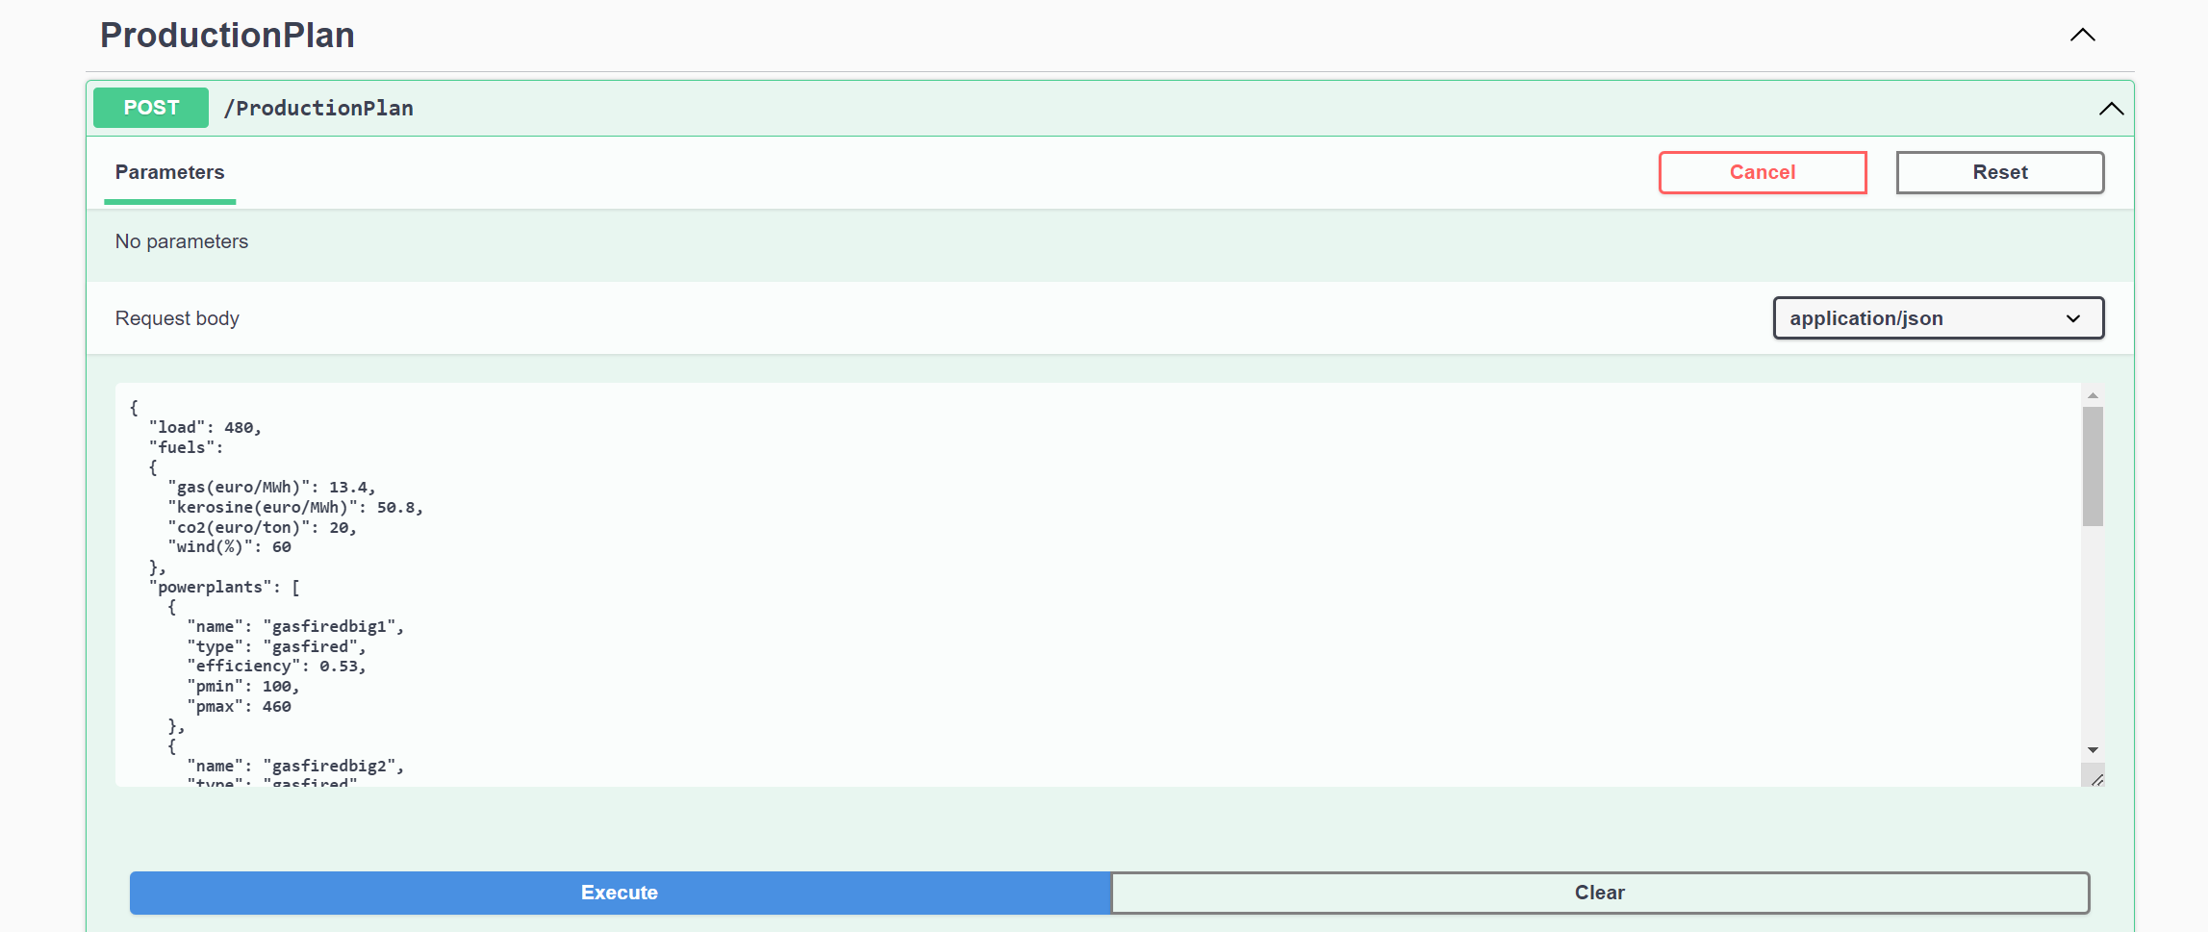

|  |
| --- |
| {  "load": 480,  "fuels":  {  "gas(euro/MWh)": 13.4,  "kerosine(euro/MWh)": 50.8,  "co2(euro/ton)": 20,  "wind(%)": 60  },  "powerplants": [  {  "name": "gasfiredbig1",  "type": "gasfired",  "efficiency": 0.53,  "pmin": 100,  "pmax": 460  },  {  "name": "gasfiredbig2",  "type": "gasfired",  "efficiency": 0.53,  "pmin": 100,  "pmax": 460  },  {  "name": "gasfiredsomewhatsmaller",  "type": "gasfired",  "efficiency": 0.37,  "pmin": 40,  "pmax": 210  },  {  "name": "tj1",  "type": "turbojet",  "efficiency": 0.3,  "pmin": 0,  "pmax": 16  },  {  "name": "windpark1",  "type": "windturbine",  "efficiency": 1,  "pmin": 0,  "pmax": 150  },  {  "name": "windpark2",  "type": "windturbine",  "efficiency": 1,  "pmin": 0,  "pmax": 36  }  ]  } |

Response

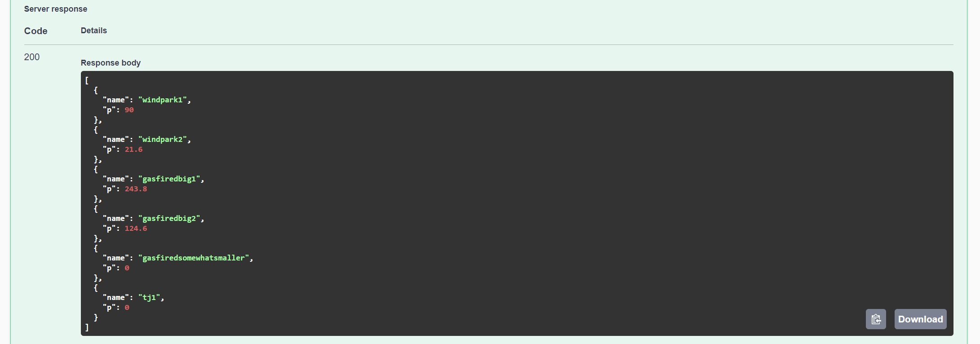

|  |
| --- |
| **[**  **{**  **"name": "windpark1",**  **"p": 90**  **},**  **{**  **"name": "windpark2",**  **"p": 21.6**  **},**  **{**  **"name": "gasfiredbig1",**  **"p": 243.8**  **},**  **{**  **"name": "gasfiredbig2",**  **"p": 124.6**  **},**  **{**  **"name": "gasfiredsomewhatsmaller",**  **"p": 0**  **},**  **{**  **"name": "tj1",**  **"p": 0**  **}**  **]** |

1. Payload2

Request

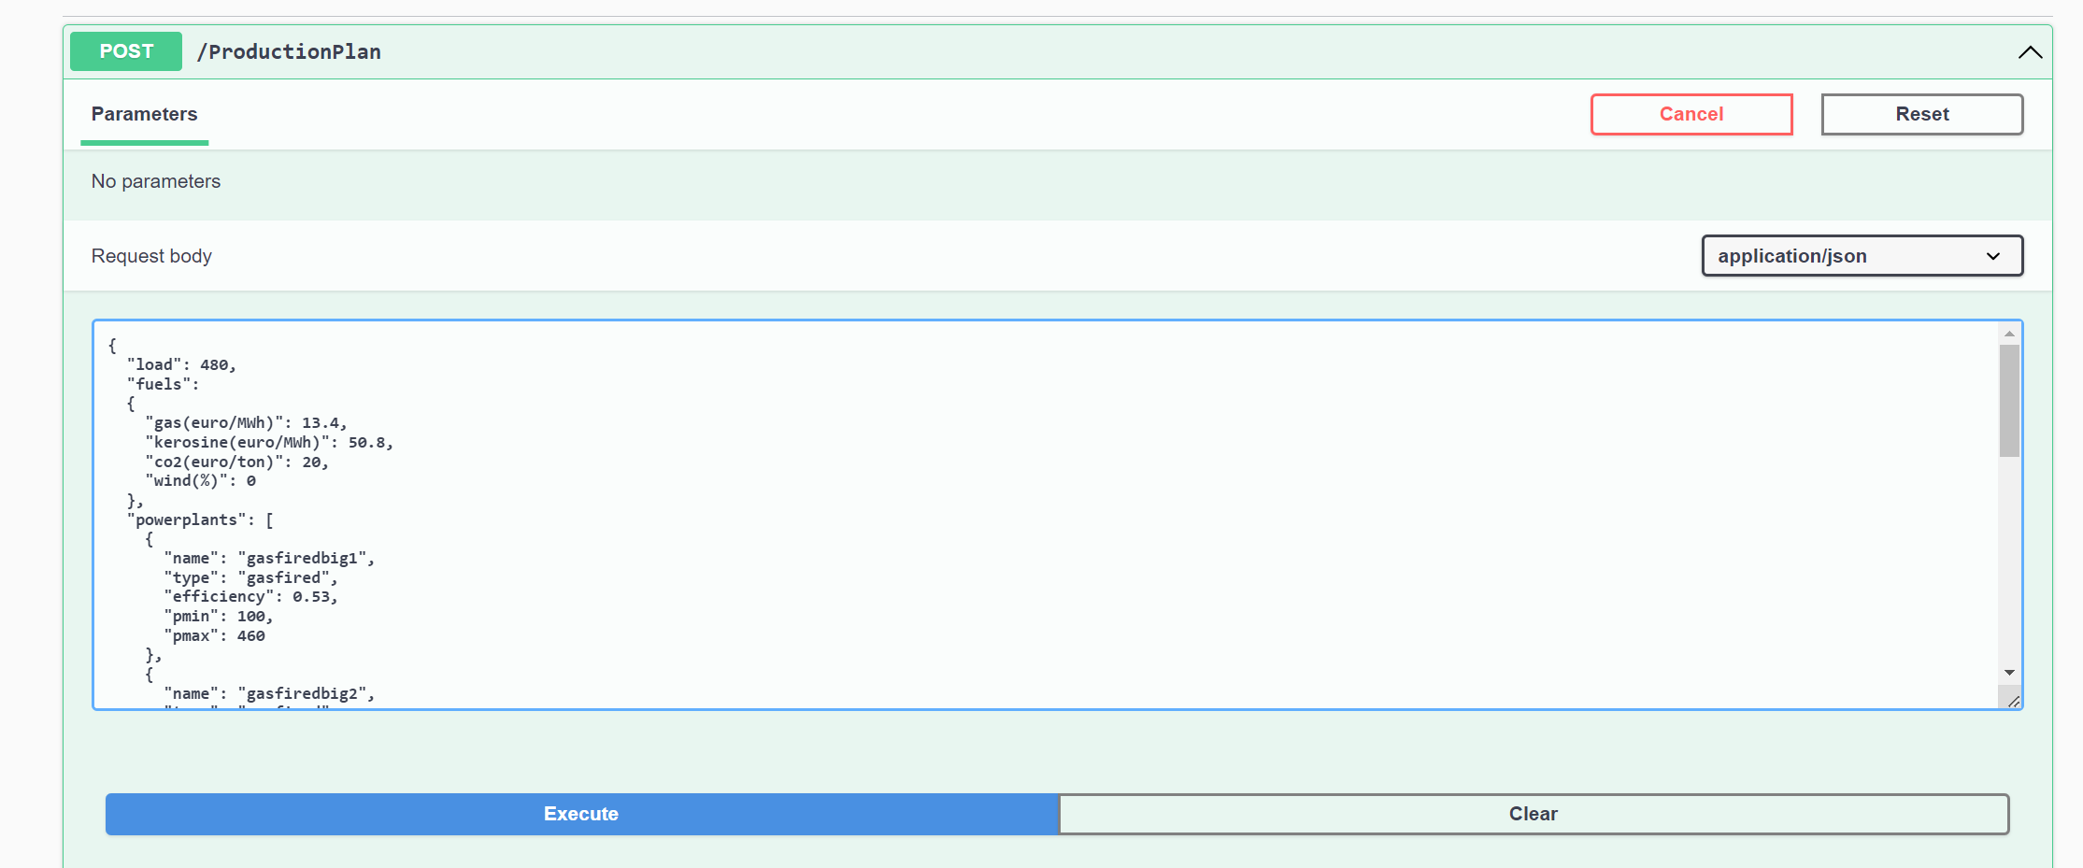

|  |
| --- |
| {  "load": 480,  "fuels":  {  "gas(euro/MWh)": 13.4,  "kerosine(euro/MWh)": 50.8,  "co2(euro/ton)": 20,  "wind(%)": 0  },  "powerplants": [  {  "name": "gasfiredbig1",  "type": "gasfired",  "efficiency": 0.53,  "pmin": 100,  "pmax": 460  },  {  "name": "gasfiredbig2",  "type": "gasfired",  "efficiency": 0.53,  "pmin": 100,  "pmax": 460  },  {  "name": "gasfiredsomewhatsmaller",  "type": "gasfired",  "efficiency": 0.37,  "pmin": 40,  "pmax": 210  },  {  "name": "tj1",  "type": "turbojet",  "efficiency": 0.3,  "pmin": 0,  "pmax": 16  },  {  "name": "windpark1",  "type": "windturbine",  "efficiency": 1,  "pmin": 0,  "pmax": 150  },  {  "name": "windpark2",  "type": "windturbine",  "efficiency": 1,  "pmin": 0,  "pmax": 36  }  ]  } |

Response

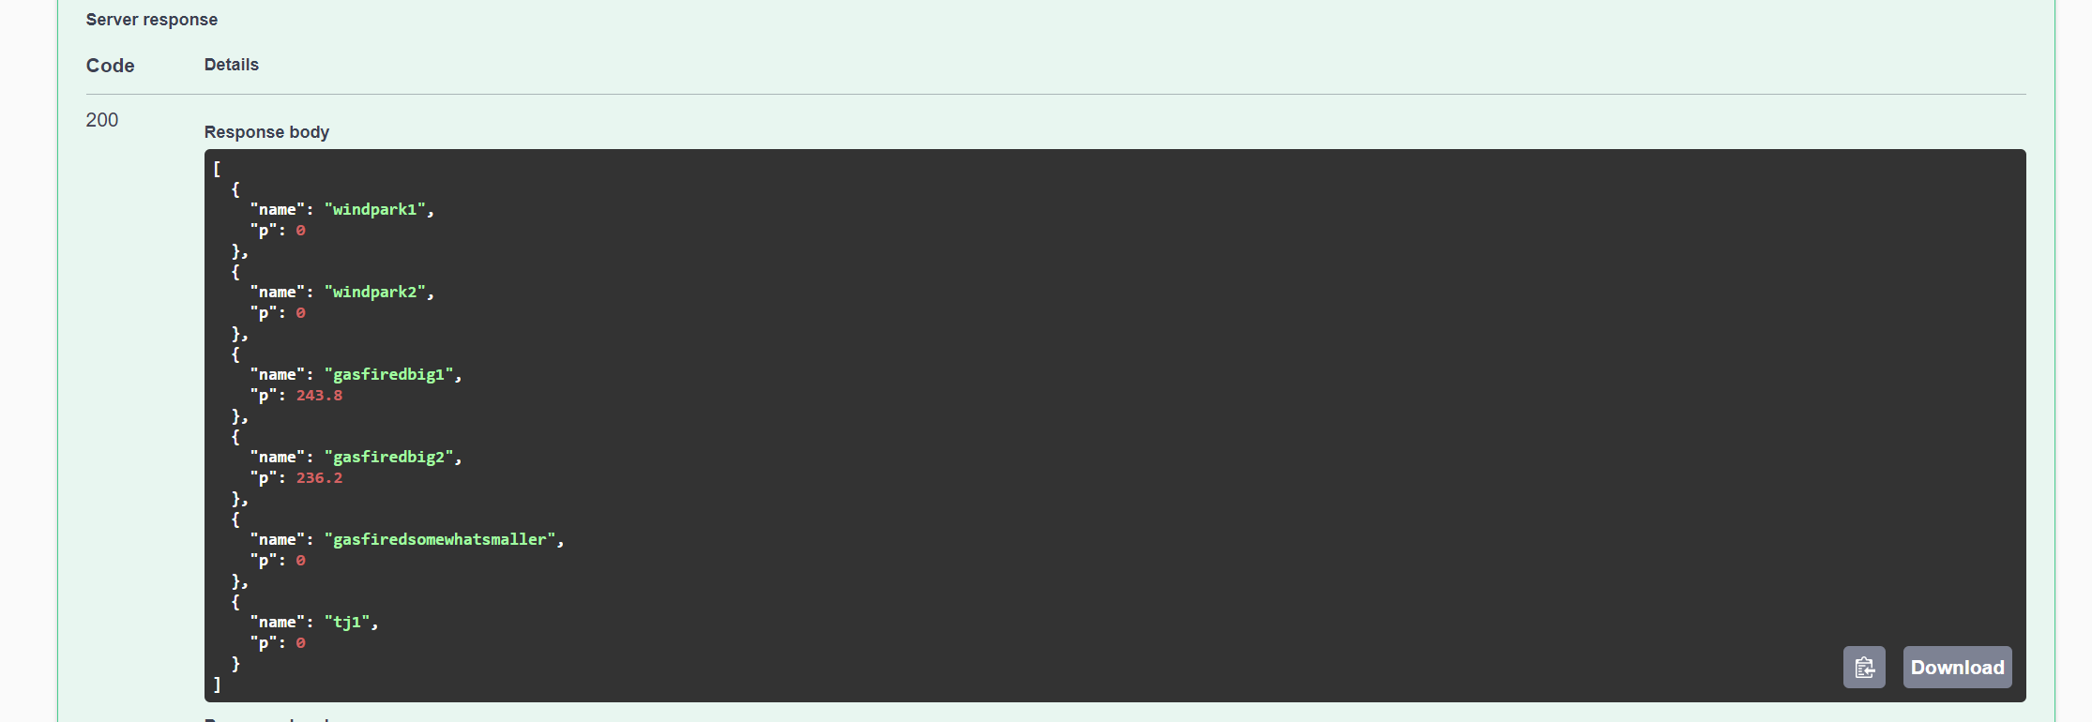

|  |
| --- |
| **[**  **{**  **"name": "windpark1",**  **"p": 0**  **},**  **{**  **"name": "windpark2",**  **"p": 0**  **},**  **{**  **"name": "gasfiredbig1",**  **"p": 243.8**  **},**  **{**  **"name": "gasfiredbig2",**  **"p": 236.2**  **},**  **{**  **"name": "gasfiredsomewhatsmaller",**  **"p": 0**  **},**  **{**  **"name": "tj1",**  **"p": 0**  **}**  **]** |

1. Payload3

Request:

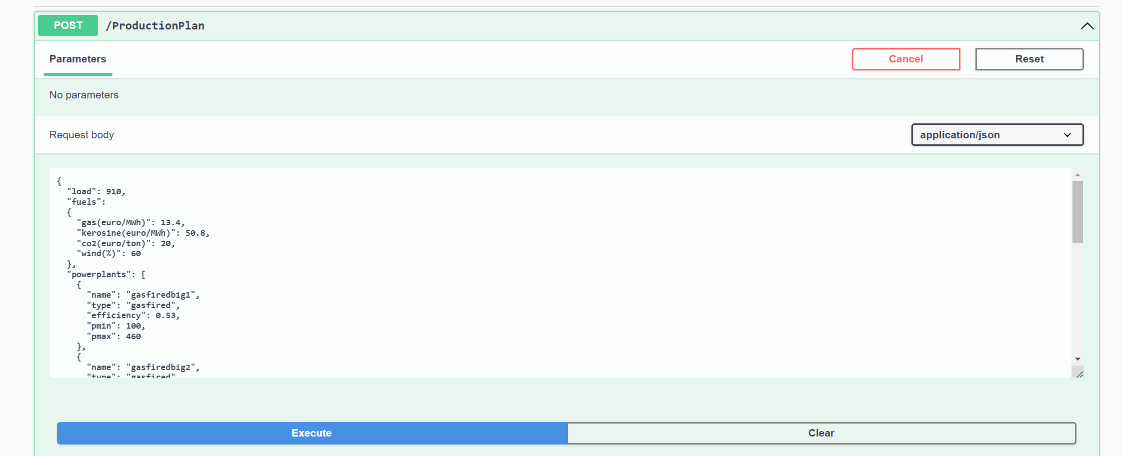

|  |
| --- |
| {  "load": 910,  "fuels":  {  "gas(euro/MWh)": 13.4,  "kerosine(euro/MWh)": 50.8,  "co2(euro/ton)": 20,  "wind(%)": 60  },  "powerplants": [  {  "name": "gasfiredbig1",  "type": "gasfired",  "efficiency": 0.53,  "pmin": 100,  "pmax": 460  },  {  "name": "gasfiredbig2",  "type": "gasfired",  "efficiency": 0.53,  "pmin": 100,  "pmax": 460  },  {  "name": "gasfiredsomewhatsmaller",  "type": "gasfired",  "efficiency": 0.37,  "pmin": 40,  "pmax": 210  },  {  "name": "tj1",  "type": "turbojet",  "efficiency": 0.3,  "pmin": 0,  "pmax": 16  },  {  "name": "windpark1",  "type": "windturbine",  "efficiency": 1,  "pmin": 0,  "pmax": 150  },  {  "name": "windpark2",  "type": "windturbine",  "efficiency": 1,  "pmin": 0,  "pmax": 36  }  ]  } |

Response

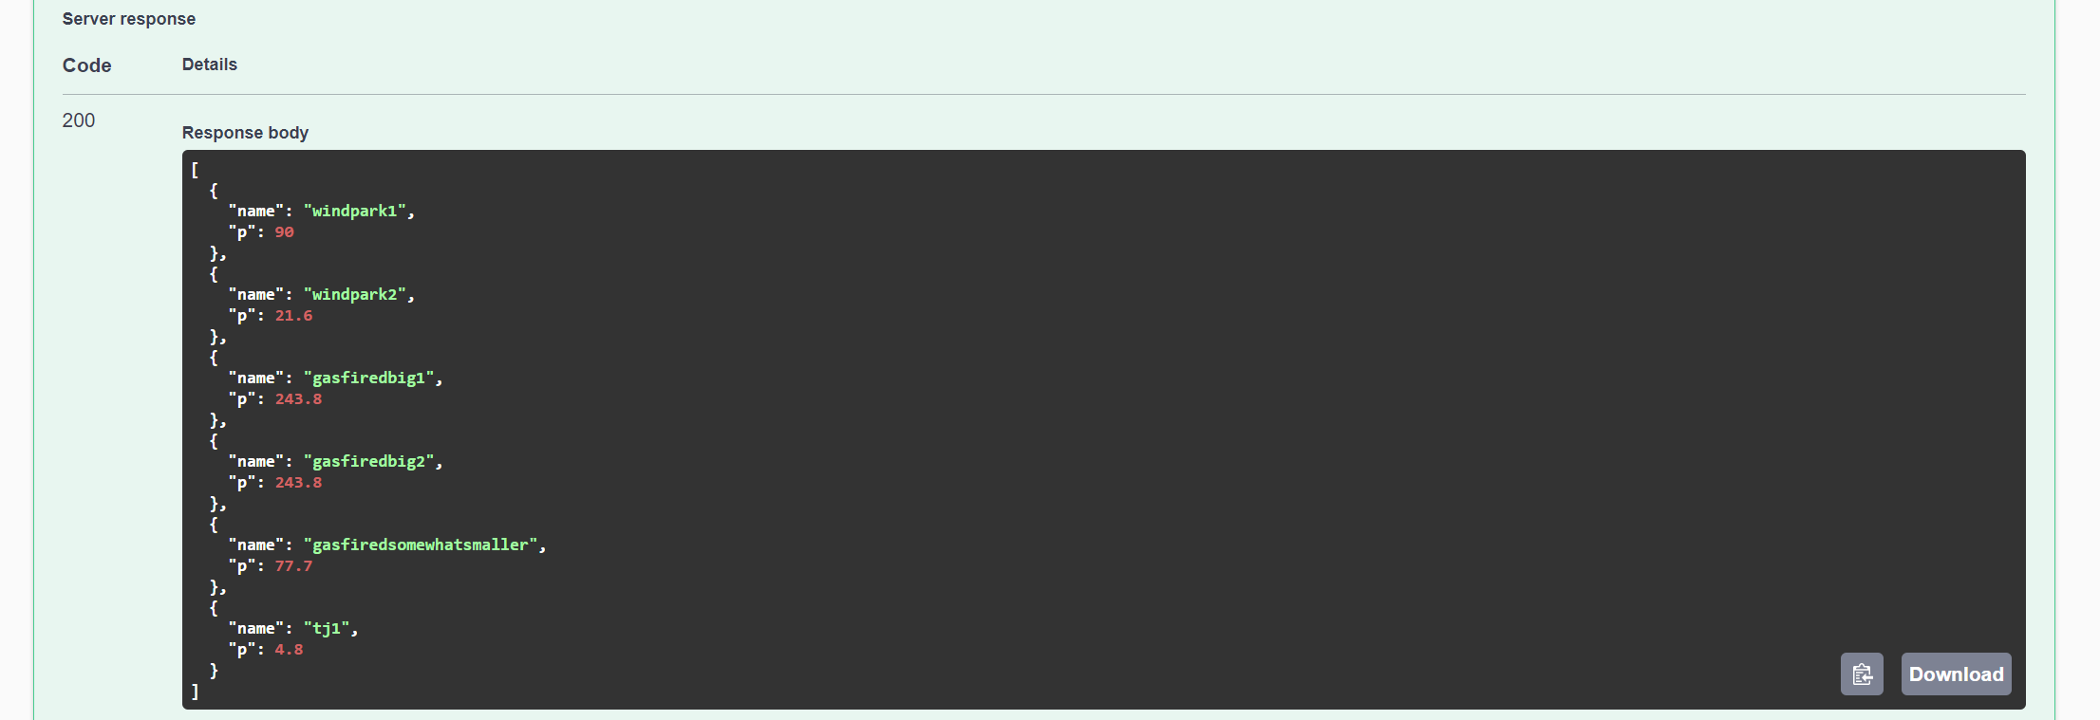

|  |
| --- |
| **[**  **{**  **"name": "windpark1",**  **"p": 90**  **},**  **{**  **"name": "windpark2",**  **"p": 21.6**  **},**  **{**  **"name": "gasfiredbig1",**  **"p": 243.8**  **},**  **{**  **"name": "gasfiredbig2",**  **"p": 243.8**  **},**  **{**  **"name": "gasfiredsomewhatsmaller",**  **"p": 77.7**  **},**  **{**  **"name": "tj1",**  **"p": 4.8**  **}**  **]** |